GOOD GOVERNANCE  BOARD MEMBER SELF-EVALUATION CHECKLIST | 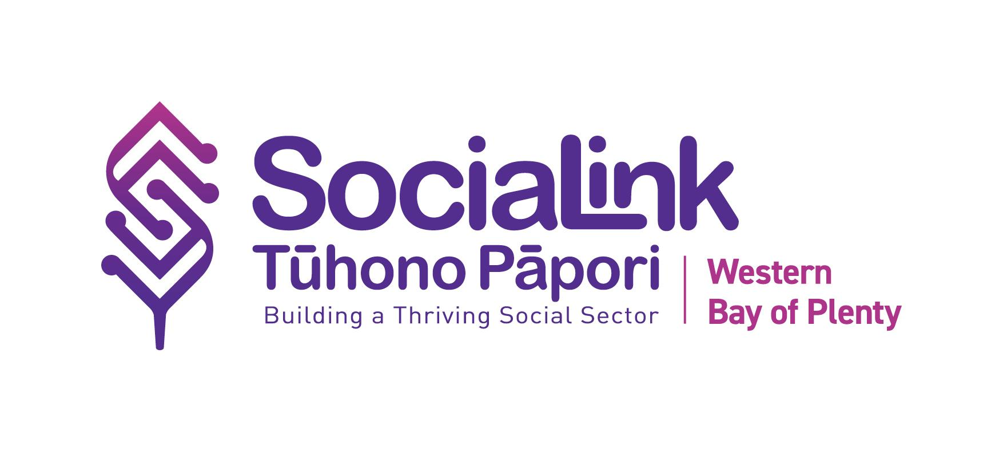

FOREWORD

This document is for individuals who want to test their understanding of governance.

Whether you are called a Trustee / Board Member / Committee Member or another title, if you are involved in governance of an organisation, then this checklist applies to you.

Governance is a big topic so this checklist covers the basics. We recommend continuing to learn and build your skills over time but we think this is a great place to begin.

In the not-for-profit / for purpose sector, good governance means leading an organisation in a way that is honest, open and responsible. It helps make sure the organisation follows the law and acts ethically.

It includes strong leadership, careful financial management and making decisions that reflect the needs and values of the community. It is key to long-term success and making a real impact.

While the core ideas of good governance apply everywhere, each organisation is different. Māori organisations may have unique features to how governance is practiced and some of these are referred to in the resources.

PROCESS

- Complete the Board Member Self-Evaluation Checklist
- Each Board member self-evaluates their knowledge against the criteria (Appendix 1).
- If you answer “No” or “Don’t Know”, also put a tick in the Action box to follow it up.
- Although the purpose of this checklist is for individual members to improve their own capability, it is likely that the checklist will flag topics that the whole Board could address together.

- Find Support to complete your Actions

If you have a “Tick for Action”, use one or more of these options:
- Ask your Administrator or Secretary;
- Check out the links to the resources given underneath each evaluation question;
- Make an appointment with a SociaLink Organisation Advisor;
- Undertake free or subsidised training through SociaLink;
- Research alternative training providers or self-help guides;
- Consider sources of funding or scholarships for your training.
APPENDIX 1

Board Member Self-evaluation Checklist

 | Yes | No | Don’t Know | Tick for Action
- Governance Process
1a. The organisation has an up-to-date strategic plan and I refer to it to ensure we are on track.

Resources
Basic Strategy Model
Strategic Plan Template 1 (shows goals)
1b. The Board has completed a self-evaluation of its progress in the last 12-24 months.

Resources
NZ Navigator is a free, self-assessment online tool.
1c. From time to time, I check our Constitution/Deed/ Rules to ensure the organisation runs to its written purpose and rules.

Resources
Trust: Charities Services register
Incorporated Society: IS Register
Social Enterprise Company: Companies Office
1d. I know how our organisation identifies, assesses and responds to key risks.

Resources
Risk & Hazard Register - Basic Template
Risk & Hazard Register - Comprehensive
1e. I understand the differences between Governance versus Management roles (if applicable to your organisation)

Resource
Governance versus Management
I am aware of Te Tiriti o Waitangi and how the Treaty applies to the work of my organisation.

Resource
Te Tiriti in Workplace and Governance

1f. I am aware of the expected behaviour/ethics in the organisation to promote a healthy culture.

Resources
Section 4 Governance Guide - Culture and Ethics
Section 1 Governance Guide - Māori Organisations
Māori Governance Toolkit
- Financials
2a. We have Financial Policies & Procedures.

Resource
Financial Policy & Procedure Template
2b. I have seen the Delegations Policy and understand it (if appropriate to your organisation).

Resource
Delegated Authority Levels Template
2c. I understand how our performance reporting works and check it at each Board meeting.

Resource
Financial Policy & Procedure Template (Clause 4.11)
2d. I understand the financial accounts - both monthly and annual accounts - and can contribute to financial discussions.

Resources
Charities Services Reporting Standards
Incorporated Societies Reporting Requirements
Business.govt.nz How to read financial statements
SociaLink’s Financial & Funding Advisor
2e. I understand the funding environment as it impacts our organisation.

Resources
SociaLink’s Financial & Funding Advisor
Charities Services - How to fund your charity
- Policies and Procedures
3a. Our organisation has a register (or master list) of P&Ps and/or I know our policies are up-to-date.

Resources
P&P Master List
CommunityNet checklist of P&Ps
3b. I know where to find the organisation’s Policies and Procedures at any time I need them.

- Induction and Recruitment
4a. I am aware of my role and responsibilities as a Board member.

Resource
Officer Resource Kit from Charities Services
4b. I confirm that I have signed the official form to say that I meet the qualification criteria for being an officer of this Trust/Society.

Resources
Trust: Officer Declaration
Inc.Society: Officer Consent and Certificate
4c. There is a succession plan, or known clear pathway, for replacing retiring Board Members.

Resources
Your Constitution/Deed/Rules What to consider in succession planning from Not-for-profit.org.nz
4d. There is a succession plan, or known clear pathway, for replacing the Senior Manager should they resign, or be away on long leave (if applicable)..

Resources: As above 4c
4e. When there are Board vacancies, the Board discusses the skills gaps around the table before recruiting a new Board member.

Resources
Board Skills Matrix template
4f. We have an induction plan or checklist for new Board members. This includes giving them a copy of the Constitution/Deed/Rules.

- Training and Upskilling Options
5a. I have noted the list of suggestions for governance training and upskilling (Appendix 2)

APPENDIX 2
GOVERNANCE TRAINING

There are many providers of governance training but listed below are the ones typically suggested to not-for-profit organisations because they are accessible and affordable.

SociaLink Tūhono Pāpori have produced a free and helpful Governance Guide covering key areas of governance. You can also add it to your Board members induction pack. Areas covered include Roles & Responsibilities, Board Composition, Culture & Ethics, Strategic Planning, Risk Management, Performance of your Organisation, Board Effectiveness, Board Integrity & Accountability, Engaging with Stakeholders and Community, Information for Māori Organisations.
LIIFT Governance Matters 2025 is a series of FREE Zoom sessions focused on governance principles for boards or committees of NFP organisations in New Zealand. The workshops are designed to be delivered in 1 to 1.5 hour sessions on very specific topics. Participants can attend one or more as needed. Each workshop will give basic principles and provide time for questions. https://www.liift.nz/governance

Community Networks Aotearoa offers online governance training to develop community organisations in good governance skills and practices. There are 10 modules and the first module is free. After that, the remaining 9 modules are $100 total and you receive a NZQA micro-credential upon completion. There is also a discount if multiple people from the same organisation takes the training programme The programme is called Tick for Governance

Sport NZ offer free “Governance 101 online training” with a high video content and takes 2-3 hours to complete. It focuses on not for profit directors on governance boards. Generally where there is a logical governance/staff separation, clarity of purpose and setting outcomes. The modules are broadly generic with limited sport specified. They are available to the wider NFP sector. Governance 101 online training

Exult Intro to Governance: Exult runs a reasonably priced workshop (BayTrust subsidises) as long as 80% of the Board is present. It runs 9.30am - 4pm and costs around $400 per group. Runs twice per annum. The programme is called Getting Your Board On Board

If you prefer not to join a public course or want one-on-one support, Exult can tailor this workshop to meet your board’s needs, including running it on a Saturday. Cost is around $3,250 plus GST (in 2025).
Telephone: 07 5718819 or contact hello@exult.co.nz

Governance in Māori organisations
The principles of governance apply to any organisation, whether it is the biggest multinational company or a small whānau trust in a remote part of New Zealand. In Māori organisations, the objectives of governance will take into account the way in which Māori relate to the assets and what they are used for. In some instances, although the organisation operates commercially, commercial objectives may be balanced with the need to safeguard the assets for future generations.
Tikanga principles may also be put into practice in the board of a Māori organisation alongside governance principles. Tikanga, kawa and values that meet the aspirations of iwi, hapu and whānau often give direction to board work. Tikanga can easily fit alongside governance best practice.
Although good governance principles and practices are universal, no two organisations are ever the same. There are also particular characteristics of Māori organisations which bring extra dimensions to the practice of governance. For more information see: What is Governance (Te Puni Kōkiri)

The Maori Governance Video Toolkit is presented by Community Governance Aotearoa to enhance the knowledge and skills of Māori Trustees. It covers:
1. Introduction
2. Māori Governance Toolkit Videos
3. Principles of Māori Governance
4. Māori Governance Structures
5. Examples of Māori Governance structure

