**Strategic** **Plan** **2023** **-** **2026**

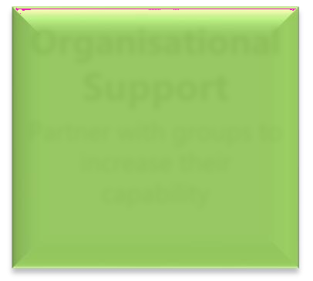

**Empower**

A collective sector voice

**Volunteering**

Build the sector by promoting volunteer opportunities

**Organisational**

**Support**

Partner with groups to increase their capability

**Training** **and** **Information**

Provide training at lowest price for accessibility

**Collaboration**

Facilitate like-minded

groups to work

to ce

gether to enhan

outcomes for all



* Engage with decision- makers to highlight and resolve priority issues.
* Social sector concerns are represented and promoted.
* Assist organisations to make submissions
* Enhance the delivery of volunteering services in the BOP
* Promote the service to sector and other community groups and businesses
* Provide 1:1 support to organisations to meet their needs.
* Update resources
* Provide training
* Provide opportunities for information sharing
* Produce a newsletter
* Actively liaise with member organisations, funders and other stakeholders
* Grow collaboration across all community sectors



**Vision:**

**Mission:**

**Values:**

A resourced, skilled and cohesive for-purpose sector enabling communities to flourish

Building the capability, confidence, sustainability and voice of WBOP community organisations

Equity

Integrity Accountability

Inclusive

Visionary Impactful



**Strategic** **Key** **Performance** **Indicators** **2023-2026**



**Empower**

A collective sector voice

**Volunteering**

Build the sector by promoting volunteer opportunities

**Organisational** **Support**

Partner with groups to increase their capability

**Training** **and** **Information**

Provide training at lowest price for accessibility

**Collaboration**

Facilitate like-minded groups to work together to enhance outcomes for all

|  |  |  |  |  |  |  |  |
| --- | --- | --- | --- | --- | --- | --- | --- |
| 1. | Engage with local, regional | 1. Increase volunteer | 1. Increase 1:1 appointments | 1. | Survey the sector to | 1. | Promote the collaborator |
|  | and national decision- | numbers by # by (date) | by 10% in (year) |  | ascertain their training |  | service through various |
|  | makers to highlight and | 2. Increase the number of | 2. Visit key groups at their |  | needs. |  | channels and using social |

resolve priority issues using



research and insights undertaken.

1. Social sector concerns and issues are represented and promoted.
2. Assist organisations to make submissions on issues of relevance to them.
3. Share and promote the voice of the sector.

organisations using the Volunteering Database by #

3. Acquire a paid admin staff

member

sites at least once a year

3. Monitor and update website resource content at least twice per annum

1. Deliver # training programmes in (year)
2. Organise at least #

member meetings

media.

2. Positive feedback from funders, suppliers and stakeholders received.