Grant Funding and also contract funding can be well managed through Xero “Tracking Categories”.
There is the facility for two tracking codes and generally the best use of this is as follows:
Tracking 1 = Funders
Tracking 2 – Projects / Programmes / Activities
When loading an Invoice or Bill, in addition to assigning the usual account code each transaction is assigned the two tracking codes so that you can allocate the income and expenses to a funder and also a project, programme or activity.
Example of Invoice
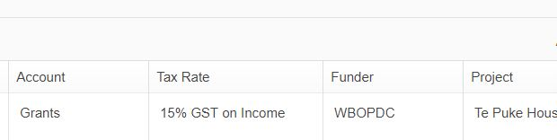

Income
Where Income is split to be allocated to different areas or part is for a specific project or activity, simply add an additional line to code the expense to a different funder or project.

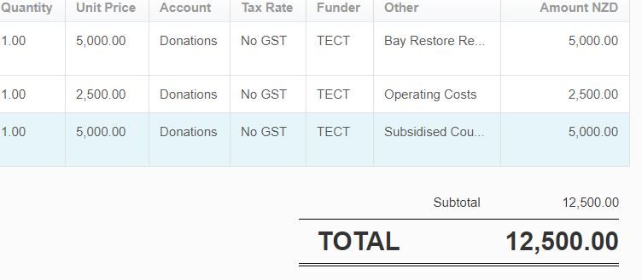
Expenses
Where an expense is to be partially allocated to a funder, simply add an additional line to code the expense to a different funder or project.
Use the total amount of the invoice as the “Unit Price” and update the “Quantity” to determine allocation of funds.

Example of Bill
In this case 40% (represented as Quantity 0.40) of the Co-ordinators time during this period has been spent on work related to a contract the organisation has with Oranga Tamariki. Oranga Tamariki is recorded as the funder and you could add the specific contract reference to track that specific funding.
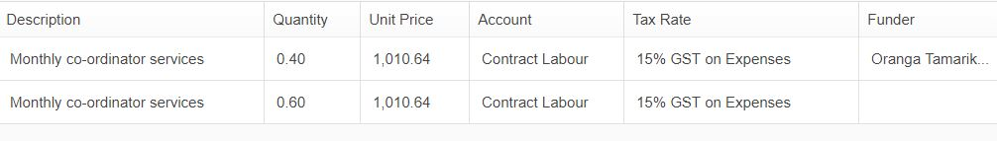
Wages & Salaries
Wages and Salaries can be apportioned to more than one funder the same as Expenses can by adding an additional line for the staff member.
Each staff member should be listed on a separate line to allow for allocation of one particular staff members wages to a different funder or more than one funder. The gross amount of the wages should be entered into the “Unit Price” field and the quantity should be added to calculate the split.
Note: The Quantity must add up to 1 for each staff member.
Calculation
If Joe Bloggs works 20 hours per week and 15 hours is to be allocated to Oranga Tamariki / DHB and the remaining 5 hours to TECT the amount would be calculated as follows:
Line 1 - Oranga Tamariki / DHB = 15 hours worked divided by 20 hours total = 0.75
Quantity added to Xero for Line 1 = 0.75
Line 2 - Grant funded hours = 5 hours worked divided by 20 hours total = 0.25
Quantity added to Xero for Line 2 = 0.25

Profit and Loss Reports
Once you start capturing this information you will be able to run a Profit and Loss Report using either of the tracking codes and using the “Show Date Range” to select the period of time you are wanting to report on and then use the “Filter” option to select your Funder & Project.
Funding Accountabilities
When using the Profit and Loss “Funder” option use the date the funding was approved as the “From:” date and either the current date or end of funding period as the “To:” date.
Then at the bottom of the screen use the “Export” button and select “Excel”. Once the document opens in an Excel spreadsheet delete the columns that apply to other funders, leaving just the first column with Income and Expense codes and the column for the Funder that you are reconciling.

