He Whakatutuki Pūtea
Wāhanga Tuatahi: Moemoeā, Whāinga & Storytelling

I am really looking forward to working with you all for the Moemoeā, Whāinga & Storytelling session at He Whakatutuki Pūtea.

Our time together will go quickly. To make sure we get the most out of the session, can you please do a little thinking (and writing and sharing) beforehand. Use the prompt questions to draft your moemoeā/vision and whāinga/mission and see next steps at the end of the document for next steps before the session on Friday 1st July.

Moemoeā/Vision
Your vision is an aspirational, and inspirational, description of WHY your organisation exists.
- It will inspire, motivate, and provide focus for your team
- It can paint a picture of your ideal future state for your team and for external stakeholders (like funders)
- It captures:
  - WHY your organisation exists for those you support
  - The difference you want to make / your ideal future state for those you support
  - The longer term change you want to see, for those you support, resulting from the work you do.
An example:
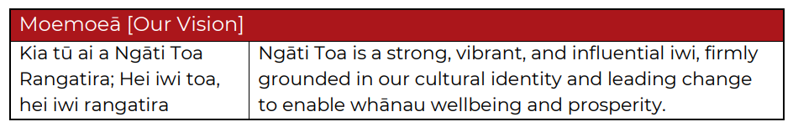

You may have a great way of articulating your moemoeā in Te Reo already. We would like to help you capture your moemoeā in English (which can take a bit of work as English words may not have the same depth of meaning).

Write your moemoeā here:

Write down your answers to the following prompt questions. You can do this by yourself first, and then share what you each create with the other members of your team.
Question 1: If your organisation was doing everything 100% right, what would things look like for those you support? | Answer 1:
Check in with answer 1. Does it describe why? Or what you do? If it’s what you do…go to Question 2.
Question 2: Look at what you’ve written for Answer 1. Ask the questions - So what? Why is that important for those we support?  Write your answer at Answer 2. | Answer 2:
Check in with answer 2. Does it describe why? Or what you do? If it’s still what you do…go to Question 3.
Question 3: Look at what you’ve written for Answer 2. Ask the questions - So what? Why is that important for those we support?  Write your answer in Answer 3. | Answer 3:

Use your answers above to create your draft vision for your organisation. What is the difference your organisation makes? Who do you make that difference for? How are they different because of the work you do? What is the ideal future state for those you support because of the work you do?

Draft moemoeā/vision:

Some tips for your moemoeā. Check these once you have written your draft vision:
- Every day, simple language, no jargon
- Short, clear and easy for everyone to understand, remember and share – one sentence, 5-15 words is your goal
- Inspires you and others
- Create a BIG purpose. It doesn’t matter whether it is achievable right now – it’s about painting a picture of your idea future state.

Whāinga/Mission
Your mission describes specifically WHAT you do. What is the work your organisation does on a day-to-day basis to work towards making your vision a reality?
An example:
The following are the 5 building blocks to help crafting a whāinga / mission. Before the session, write down your answers to the prompt questions for your organisation.

Action(s)
What are the high-level actions that describe what your organisation does? e.g. To inspire…, Celebrating…, To support…, To educate… etc.

Who benefits from the work you do?
Who do you support? Who does the work of your organisation help? Who benefits from your work the most?
Services / Work you do
What is the broadest way to describe the work your organisation does? What services / programmes / activities does your organisation provide?
Problem(s)/Need(s)
What specific problem or need is your organisation solving with the work you do?

Cause
Is there an overarching cause you support? e.g. education, conservation, equality

Use your answers to create your draft mission for your organisation. You don’t need to include all 5 building blocks in your mission. Select the 2 to 3 building blocks that, for you, best answer the question ‘what does your organisation do?’.
Draft whāinga/mission:

Some tips for your whāinga. Check these once you have written your draft mission:
- Clear, simple, plain language
- Short, clear and easy for everyone to understand, remember and share – 20 words max
- 2-4 building blocks (max 5)
- Useful (inform, focus, guide)
- Recognisably yours

Here is an example of moemoeā, whāinga and tikanga (values) shared together:
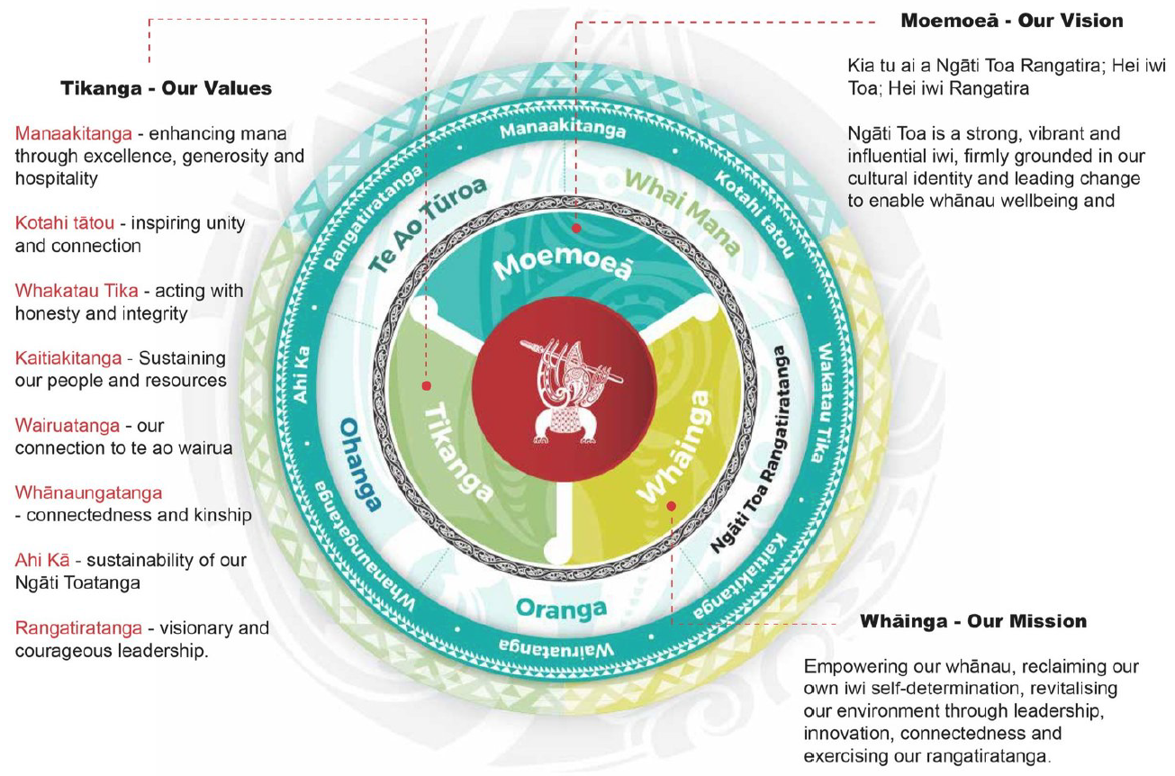

Next steps
(Irene I would love to chat with you about next steps for this template vs. time we have in the hui)

Bring your draft moemoeā and whāinga with you to the session
OR
Send your draft moemoeā and whāinga to Irene (irene@socialink.org.nz) by Monday 27 June if you would like feedback before the session.
Or
Where you have the chance to craft your moemoeā and whāinga with input from your wider team before the session, send team members the template and ask them to complete. Then get together and use each persons ideas to help you craft your moemoeā and whāinga:
Focus on your whāinga first
- Each member of your team shares the draft whāinga they have created with the rest of the team
- Team discusses which words/framings they like best to create your organisations draft whāinga

Focus on your moemoeā next
- Each member of your team shares the draft moemoeā they have created with the rest of the team
- Team discusses which words/framings they like best to create your organisations draft moemoeā

Send your draft moemoeā and whāinga to Irene (irene@socialink.org.nz) by Monday 27 June if you would like feedback before the session.

If you have any questions at all give me a call on 021 509 944 or email me at megan@exult.co.nz. See you Friday 1st July.

Ngā mihi mahana
Megan

