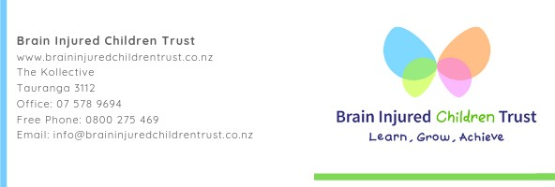

Looking for a brilliant Chairperson
The Brain Injured Children Trust ‘s mission is to empower families/ whanau by providing life changing resources that will enhance the quality of life for their brain injured child. We provide insight and funding for a range of NDTP- neuro development therapy programmes. The organisation is in an unique position to be able to provide people with lived experience to work alongside families and are making a real difference in their lives. We let them know that they do know what’s best for their child and that we believe in them.
We have recently developed a new Board that is passionate and enthusiastic about our Mission and doing great things.
We are now recruiting an experienced Chair. (this is a voluntary position) We need:
- An experienced Not for Profit chair with a strong passion for the mission, vision, and values
- Excellent Governance skills and a passion to grow governance and the organisation
- Time to dedicate to developing the organisation from being a small local organisation to its full potential
We are a small national, registered Charity with two staff, based in Tauranga and meet every second month and we are looking for a person to help us set direction and strategy and ensure we have adequate resources and provide fiduciary oversight. Our expectations are the Chair will be available for all meetings and have time to develop board members.
More information is available on our website:
https://www.braininjuredchildrentrust.co.nz/
Or Shirley Wilson at 027-628-4858 Applications to shirley@braininjuredchildrentrust.co.nz

