Summary | To ensure a safe and healthy environment is maintained at all times everyone must:  - take individual responsibility for health and safety practices  - comply with occupational health and safety legislation and regulations  - be familiar with and observe all safe work policies, procedures and instructions  - promote and participate in health and safety, maintain a safe workplace, and ensure that all equipment is used correctly at all times  - take responsibility for their own health and safety and ensure no action or inaction on your part harms other in the workplace
Responsibility | The CEO/Manager, and Administrator will:  - commit to the provision and maintenance of a healthy and safe workplace;  - consult and participate in the health and safety program;  - use risk identification, assessment and control principles to reach name of organisation’s health and safety objectives;  - inform and train all people to whom this procedure applies in relevant policies, procedures and health and safety obligations; and  - participate in name of organisation's inductions and implement all safety procedures.  The CEO /Manager will:  - coordinate the identification, development, implementation and review of Work Health and Safety policies and procedures;  - assist supervisors/managers in the identification, assessment and selection of measures to control hazards and risks to health and safety;  - assist supervisors/managers in monitoring and evaluating hazards and risk control measures;  - assist supervisors/managers in the identification, development and provision of appropriate Work Health and Safety -related information, instruction and training;  - monitor and advise on legislative and technical changes relating to health and safety;  - flag any Health and Safety issues to the CEO when necessary;  - include Health & Safety report in any board updates  The Administrator will:  - file copies of Health and Safety documentation;  - flag any Health and Safety issues to the CEO/Manager when necessary.  Team Members (Contractors, Board Members, staff & volunteers ) will:  - participate in health and safety training, actions and activities and support name of organisation in its efforts to reach its health and safety and, where relevant, rehabilitation objectives;  - follow reasonable health and safety instructions from managers or supervisors;  - report any serious incidents, accidents, injuries or hazards in the workplace to supervisors or designated representatives;  - aim to work in a way that does not endanger the health or safety of themselves or others;  - properly use and maintain safety equipment;  - make sure visitors follow safety rules in the workplace; and  - participate in name of organisation induction programs and implement all detailed safety procedures.  External Contractors to name of organisation will:  - assess risks to their health and safety arising from the provision of their services;  - have control measures in place to address those risks, including complying with any relevant name of organisation policies and practices.  Delete Health & Safety Representative section if not applicable  The role of the designated Health and Safety Representative is to:  - investigate any health and safety related complaints that occur during the specific project and refer them on to the CEO;  - report back to team members on any matter relating to health and safety;  - discuss with team members, any proposals or matters which may affect the health and safety of participants;  - manage in the identification of hazards, the assessment of risks and implementation of risk control measures;  - promote the adherence to health and safety policies and procedures;  - monitoring of risk controls and health and safety policies and procedures  - facilitate regular Health & Safety “Toolbox” meetings  A designated Health & Safety Representative is someone chosen by other workers to speak or act on their behalf about health and safety matters. The elected person should receive external training to carry out this role.
Procedure | 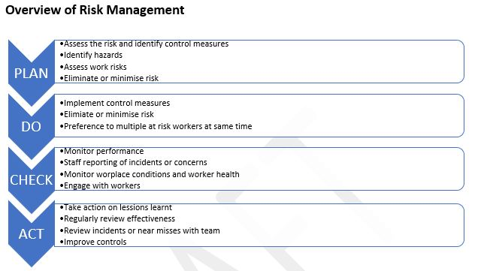  CHECK  Step 1: Hazard Identification and Control Procedures  - Identify all hazards in your place of work. Review the “Health & Safety Risk Assessment Template” and record the details on the “Risk & Hazard Register” form.  - Identify all plant, machinery and equipment individually  - Identify the “potential harm” for each hazard  - Some hazards may cause a variety of harm so list the harms individually  - Determine whether the hazard is a “significant hazard”, i.e. can it cause serious harm?  - Evaluate each hazard to determine whether it is practicable to Eliminate, Isolate or Minimise  We will ensure:  - All hazards and the hazard controls will be regularly assessed  - All employees are aware of emergency and evacuation procedures  - Good work practices are used and maintained  - Employees are properly trained and/or supervised  - Any new hazards identified, are incorporated into Hazard Register and all employees informed  - Any new machinery/equipment/chemicals are assessed before use, and safety controls/practices are established  - Protective clothing and equipment is provided and used by all employees, at all times necessary  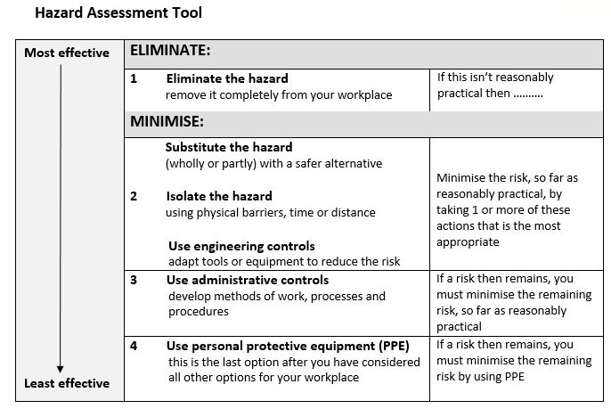  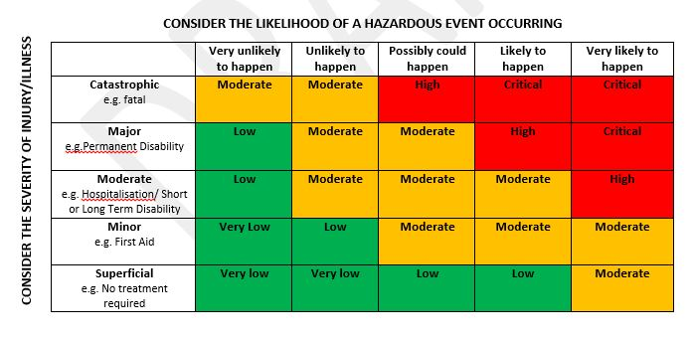  Step 2: Information and Training  Employee & Employer Responsibilities  Every employee shall take all practicable steps to ensure:  - Their own safety while at work; and  - That no action or inaction of the employee while at work, causes harm to any other person(s).  All employees are to be aware of:  - The hazards they will be exposed to in the workplace, and the hazard controls or procedures to be taken to prevent any harm or damage to themselves, other person(s) and property.  - What to do in an emergency.  - Where all necessary safety gear or safety equipment and materials are kept.  To ensure that we are complying and maintaining this system, we will:  - Ensure new, and existing staff read and understand our Health & Safety Procedures.  - Ensure Health & Safety Procedures are available and accessible to all new, and existing employees.  - Review Health & Safety Procedures at least annually, or as environmental factors change.  - Maintain records to ensure all staff have read and understood our Health & Safety Procedures.  STEP 3: Accident / Incident Reporting and Investigation Procedures  - All accidents and incidents must be notified to the CEO immediately. If any accident or incident is not notified on the day it happens, then it may not be accepted as a work related injury.  - Do not disturb the scene!  - All accidents and incidents must be recorded in the Accident / Incident Register  All serious harm accidents are to be notified to WorkSafe as soon as possible.  Phone: 0800 030 040 (24/7) Online forms: https://worksafe.govt.nz/notify-worksafe/  - Refer to related document “WorkSafe What events need to be notified?” for specific examples of notifiable accidents, illnesses and incidents  - If there has been a death WorkSafe must be notified immediately  - A “Notice or Record of Accident/Serious Harm” form, is to be provided to WorkSafe within seven (7) days of the event.  - Inform all employees of the outcome of the accident/incident investigation, i.e. new hazard identified and the hazard controls.  GENERAL  Health and Safety Forums  Where the organisation is not required to establish a Health and Safety Committee, and does not otherwise establish such a Committee, the organisation may conduct regular Health and Safety forums. Details of all forum must be recorded and stored with Health & Safety documentation.  Review of Policy and Procedure  This Health & Safety Procedure will be reviewed annually by the CEO/Manager in consultation with the Board.  The review will involve assessing the effectiveness of the procedures by:  - reviewing overall health and safety performance; and  - monitoring the effectiveness of policies and procedures.  Dissemination of Policy and Procedure  - The Health & Safety Policy and related procedures will be displayed on our website and all team members will be provided with a copy by their supervisor/manager  - New team members will be provided with a copy of the documents as part of their induction  - The policy and related procedures will be reviewed on an annual basis or more frequently, if required, to ensure continued compliance with the relevant legislation
References
Related Policy | Health & Safety Policy v1  Health & Safety Policy Condensed (for website)
Reference Documents | Preventing & responding to bullying in the workplace - https://worksafe.govt.nz/topic-and-industry/bullying-prevention-toolbox/good-practice-guidelines-preventing-and-responding-to-bullying-at-work/  Notifiable Events - https://worksafe.govt.nz/notifications/notifiable-event/what-is-a-notifiable-event/
Forms / Templates | Risk & Hazard Register  Worksafe First Aid Register  Worksafe Accident Investigation Form
Links | https://worksafe.govt.nz/the-toolshed/tools/writing-health-and-safety-documents-for-your-workplace/  https://worksafe.govt.nz/the-toolshed/definitions-and-acronyms/  www.legislation.govt.nz  www.acc.govt.nz

